License Agreement

Power of Attorney Statement

I, the signee, am working on the project ''Deep Learning for Natural Language Processing'' under the supervision of Prof. Dr. Bela Gipp. The specified project involves the creation of software and documentation that shall be placed under an open source license.

I hereby grant Prof. Dr. Bela Gipp full authorization to perform any legal acts necessary, including making declarations on my behalf, in order to irrevocably place any software and documentation created as a result of my project under an open source license, e.g. Apache 2.0. The type of license remains at the discretion of Prof. Gipp, as long as it is an open source license. I am aware that this will permanently exclude any commercial exploitation of my copyrights.

I hereby confirm that I have read and understood the Apache Licence 2.0 at: https://tldrlegal.com/license/apache-license-2.0-(apache-2.0)#fulltext

Goettingen, 2023-09-04

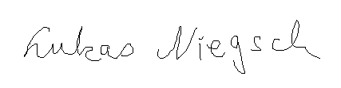
Lukas Niegsch

